

**MANSOURA UNIVERSITY**

Faculty of Computer and Information Systems

Information Systems Department

**iPhone Application for Community Services (**[**sanay3y.com**](http://Sanay3y.com/)**)  
SANAY3Y**

**By**

Asmaa Samir Bilal (4472)

Asmaa EL-Bialy El-Said (4471)

**Under the supervision of**

Dr. Haitham A. El-Ghareeb  
Lecturer at the Department of Information Systems

*Submitted in partial fulfillment of the requirements of B.Sc. Degree in Computer Science*

July 2012

**ACKNOWLEDGEMENT**

Failure is one of situations that is really hard for the human to adapt with, especially if it is frequent and consecutive. Sanay3y project was not our first attempt, not even the second btw. We have tried on several previous projects, and we used to stop at a black spot that we do not know where to go then, particularly at this point we owe our deepest gratitude to Allah SWT for assisting us throughout this and giving us Certainty, Strength and Helpers which were the major reasons for us to continue trying.

Certainty: We had a certain hope in Allah, that we will find a workable idea that we will work on until we reach its end and achieving a good outcome. We also had a deserved certain in our supervisor that he will never let us fall, and he will be there for us until we reach.

Strength: Allah gave us the strength to get out of each attempt with a smile on our faces and a determination to start looking at the following idea. Alhamdul-Allah frustration never found its way to us, and this also is credited to our supervisor who used to say after every attempt “ *There is still plenty of time*”!

Helpers: One of the most important Allah grants to us was our supervisor, explicitly This project would not have been possible without his help . Dr. Haitham El-Ghareeb (the owner of the idea), he really deserves our thanks and appreciation. Thanks For his patience, actually we was one of the most onerous Groups. And appreciation for his great enthusiasm towards the project and his permanent support which have always given us a great push towards work.

**ABSTRACT**

Mobile phones have changed the lifestyle of many consumers, especially those in younger generations. Mobile phones offer a range of applications, from telephone conversation and simple text messages (SMS), to multimedia messaging services (MMS) and Internet access, depending on the capability of individual mobile phones and the services available. These applications have been made possible through various developments in mobile telephone technology such as GPRS, WAP and the 3G standard .

Lately in Egypt, communities have evolved to help move our precious country forward. One of the important initiatives is the one available at www.sanay3y.com. This initiative tends to help many people in Egypt finding work, seeking better jobs, especially those who don't have daily jobs by allowing them to add their names and location and also their communication methods in a common place to make it easier for the user to have a fast and easy access to this data .

This project focuses on creating iPhone Mobile Application that presents the service provided by the www.sanay3y.com website broader and wider. Since mobile phone are more widespread than computers, its use in such a service is sufficient to make it more widespread and more efficient to .

**TABLE OF CONTENTS**

**List of Figures................................................................................................................................vi   
Chapter 1. Introduction...............................................................................................................1**

* 1.1.  Overview ................................................................................................................................................2
  + 1.1.1. Need for The Project……………………………………………………………………...2
* 1.2.  Scope, Aims and Objectives.............................................................................................................3
  + 1.2.1.  Scope .............................................................................................................................. 3
  + 1.2.2.  Aims ................................................................................................................................4
  + 1.2.3.  Objectives .....................................................................................................................4
* 1.3.  Integration Between Mobile and Web ......................................................................................4
* 1.4.  Thesis Structure …..............................................................................................................................5

**Chapter 2. Methodology .............................................................................................................6**

* 2.1.  Overview ................................................................................................................................................7
* 2.2. Method………………………………………………………….……………………………………..………...7
* 2.3. Tools ………………………………………………………………………………………………………………9
  + 2.3.1. Hardware……………………………………………………………………………………...9
  + 2.3.2. Software……………………………………………………………………………………….9

**Chapter 3. Mobile Components .............................................................................................11**

. 3.1.  Overview ......................................................................................................,.......................................12

. 3.2. User Requirements ……………..………….……………………………………………………..………12

. 3.3. User Interaction With Mobile Application………..……………………….……..………………13

* 3.4. The Code ………………………………………………………………………………………………………15
  + 3.4.1. JavaScript Code Samples ……………...…………………...…………………………15

**Chapter 4. Design Components** **.............................................................................................21**

* 4.1. Overview …………..………………….………………………………………………………………………22
* 4.2. Importance of Mobile Design…………………………………………………………………….……22
* 4.3. Logo Design and Application Buttons ……………………………………………...………….…23
* 4.4. Mobile Layout……..……………………………………………………………………..…………….……24

**Chapter 5. Integration Between Web and Mobile …………………....................................25**

* 5.1. Overview …………..………………….………………………………………………………………………26
* 5.2. Introduction ………….………………………………………………………………………………….......26
* 5.3. Integration ……………..………………………………………………………………………………….....28
* 5.4. Software Architecture Integration Techniques ...…………………………..………………...28
  + 5.4.1. Standard Enterprise Wide Software …………………………………………….29
* 5.5. Code Samples ………………………………………………………………………………………………32

**Chapter 6. Project Outcome** **...................................................................................................34**

**Chapter 7. Conclusion and Future Work ...........................................................................36**

* 7.1. Conclusion …………..……….……….………………………………………………………………………37
* 7.2. Future Work …………..……….……….……………………………………………………………………38

**Chapter 8. References ..............................................................................................................39**

**LIST OF FIGURES**

Figure 1.1. Sanay3y Context Diagram ………………………………..……………………………………...4

Figure 2.1. sanay3y project methodology ………………….……………………………………………...8

Figure 2.2. macBook ………………………………………………………………………………………………...9

Figure 2.3. TitaniumStudio Icon ……………..…………………………………………………………….…..9

Figure 2.4. MAMP Icon ………………………………..…………………………………………….……………10

Figure 3.1. sanay3y project use case ...……………………………………………………………………..13

Figure 3.2. Adding process Activity diagram ………..….………………………………………………14

Figure 3.3. Adding textField Code …………….…………………………………………………………….15

Figure3.4 Code Sends the user data to the web server………...……………………………………16

Figure 3.5. Searching function 1/2 ………………………………………………………………………….17

Figure 3.5. Searching function 2/2 ……………………….…………………………………………………18

Figure 3.6. Show All Function 1/2 …………………………………………………………………………..19

Figure 3.6. Show All Function 2/2 …………………………………………………………………………..20

Figure 4.1. The main character in Sanay3y application …………………………………….……..23

Figure 4.5. Sanay3y Application Layout …..…………….………………………………………………..24

Figure 4.6. Real Application …………………….…………….………………………………………………..24

Figure 5.1. The boundary between the system and the environment ………………………..27

Figure 5.2. Integration Between Web And Mobile ………………………….…………………….…28

Figure 5.3. Integration Techniques …….………………….………………………………………………..29

Figure 5.4. Three Tier Architecture …………………………………………………………………………30

Figure 5.5. Three Tier Architecture of Sanay3y ………………………………………………………..31

Figure 5.6. Add API ………………………………………………………………………………………………...32

Figure 5.7. Advanced Search API …………………………………………………………………………….33

Figure 5.8. Show All API …………………………………………………………………………………………34

Figure 6.1. Sanay3y Application Flow ……………………………………………………………………..35

**Chapter 1. INTRODUCTION**

**Chapter 1. INTRODUCTION**

**1.1. OVERVIEW**

M

obile phones are efficient communication devices and make life easier. Whether locating a friend or following up with a new contact, mobile phones allow you to connect to people in any part of the world. New mobile-phone models are constantly engineered to meet the needs of consumers and now have multifunctional tools that may be useful in everyday life.

Mobile phones' basic function, of course, is to allow you to talk to another person while you're almost anywhere. You can place and receive calls and messages by simply pressing a person's name in your contact list, eliminating the need for memorization or a separate address book. The ability of mobile phones to connect to people in other countries helps family and friends who are from far from one another stay in touch.

Mobile phone applications extend the functionality of mobile phones. Word and spreadsheet processors are available, and those who may need on-the-go computing may find this a great benefit of mobile phones. Standard mobile phone applications include alarm clocks, calculators and even more, applications that provide web services, all of which surely help our productivity.

* + 1. ***Need for The Project***

Since cellular phone networks have become key tool used by researchers as they try to locate people all over the world for several purposes. This research presents an overview on the accomplished in the field of creating an iPhone application whose aim

was to provides a web service that will help many people to have a fast and easy access to required data which belong to other people, in a Mutual benefit manner.

This project consisted mainly of three phases, the first of which was to design logos and application icons and use them to build an effective user interface in the second phase. The third phase involved writing a web service, which is to be called in the background, while the user is using their mobile phones.

The remainder of this chapter provides a review of the aim, the main objectives of the project, and simple intro to the Web Services Enhancements Integration Architecture.

**1.2.**  **SCOPE, AIMS AND OBJECTIVES**

***1.2.1. Scope***

In the midst of all the buzz surrounding Apple, iPhone application development trends are beginning to shift towards business use cases, according to a study by iPhoneAppQuotes.com. This project focuses on building a business iPhone App that tends to help many people in Egypt finding work, seeking better jobs, especially those who don't have daily jobs. The project has been divided into four main phases as follows:

1. **Design logo and Application icons:** involves designing logos that converge with the site ones and give the same impression, and designing icons that give an appropriate form for the application.
2. **Application building:** it entails building the application, which allow the user to add new “Sanay3y” or search about one. The interface was built using the designed logos and icon photos from the first phase build an Interactive interface.
3. **Writing the web services:** involves writing services that will return back with the desired output.

***1.2.2. Aim***

The overall aim of the project was to build an iPhone application which offers the same service provided by the sanay3y.com website, which is allowing the craftsmen to add their data in an easy access place so that every one can reach it when needed.

***1.2.3 Objectives***

The main objectives behind this project can be summarized as follows:

1. Showing all craftsmen currently available data
2. Provide advanced search about the craftsmen depends on their region or their profession.
3. Allowing craftsmen or any other one to add craftsmen data.

**1.3. INTEGRATION BETWEEN MOBILE AND WEB**

Web services are widely used in current web-based business applications, and form the basis of emerging frameworks in Grid computing. Current mobile agent systems implement similar (often proprietary) mechanisms for service description, invocation and discovery.

**Figure1.1** represents the context diagram explaining this operations in our Sanay3y application, will talk extensively about this in **Chapter 5** .

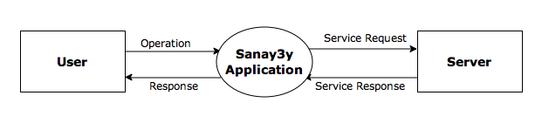

**Figure 1.1. Sanay3y Context Diagram**

|  |  |
| --- | --- |
| Symbol | Description |
| Square | Represents internal data source or data destination |
| Vowel | Indicates an internal intity or transfer mation process |
| Line | A line with an arrow indicates the direction of the flow of data |

**Table 1.1. Tabular description of the Context Diagram**

**1.4.  THESIS STRUCTURE**

The remainder of this documentation is organized as follows:

1. **Chapter 2.** **Methodology:** presents the detailed project methodology, procedure and tools used, and the steps performed to implement and achieve the results of the application.
2. **Chapter 3.** **Mobile Component:** describes how the proposed solution is developed and implemented, while presenting the major algorithms used.
3. **Chapter 4.** **Design Components:** describes the importance of mobile design, Reviews some of the pictures, logos, and icons designed for the application, and layouts of the work
4. **Chapter 5.** **Integration Between Web and Mobile Components:** describes the importance of integration between web and mobile and presents the integration method used in the application.
5. **Chapter 6.** **Application Outcome:** view some of screen shots of the Application output.
6. **Chapter 7**. **Conclusion and future work:** concludes the entire conducted research and the delivered results and their limitations, suggesting enhancements and additions to the current research.

**Chapter 2. METHODOLOGY**

**Chapter 2. METHODOLOGY**

**2.1. OVERVIEW**

O

ver the years, even those involved in managing projects have observed that projects have common characteristics that can be formalized into a structural process, which allows them to manage projects more effectively. Each phase can typically be brought to closure in some logical way before the next project phase begins; and each phase results in discrete milestones or deliverables, which provide the starting point for the next phase, this chapter will presents the detailed project methodology, procedure and tools used, and the steps performed to implement and achieve the results of the application.

**2.2. METHOD**

The project methodology consisted of conducting three phases: (a) understanding the environment and collecting the data, (b) building the application interface, and (c) building the web services . The understanding and collecting data phase was the most important phase which aimed at finding good means that explain the environment and how to deal with it. The experience gained from the first phase used then to build the application in the next phase. After building the application we needed to build our own web services to provide integration between the application and the web .

Collecting data and understanding the environment

Building the application

Building the web services

**Figure 2.1. sanay3y project methodology**

1. **Understanding The Environment And Collecting The Data.**

In this phase we relied on Appcelerator Titanium Smartphone App Development Cookbook by [ Boydlee Pollentine ] and Linda's CDs, which reviews a simple explanation of working with Titanium and basics of java script programming language .

1. **Building The Application Interface.**

In this phase we used Titanium Appcelerator to build the application interface that Determines where interaction between humans and machines should occurs and how the application GUI will look, Also MAMP was used that helped us develop our application locally, I will include more details about them at the Software section in the current chapter.

1. **Building The Web Services.**

Typically, services are console applications that are designed to run unattended without a graphical user interface (GUI). However, some services may require occasional interaction with a user. In our case the Web service will be a craftsmen lookup or adding service that takes in queries, then query an internal database and respond appropriately. A web-based client will also be coded in Java Script to communicate and query the server. PHP was used to code our services.

**2.3. TOOLS**

***2.3.1. Hardware***

1. **MAC**

Since the project was building an iPhone application the MAC was essential in our work because the iPhone SDK works only on OSX operating system.



**Figure 2.2. macBook**

***2.3.2. Software***

1. **Titanium Appcelerator**

In this project we used the Titanium Appcelerator platform to build our application, Appcelerator Titanium is a platform for developing mobile, tablet and desktop applications using web technologies, it is one of several [phone web based application framework](http://en.wikipedia.org/wiki/Multiple_phone_web_based_application_framework) solutions allowing web developers to apply existing skills to create native applications for iPhone and Android.



**Figure 2.3. TitaniumStudio Icon**

1. **MAMP**

As a web developer we have to test our programs in detail. In addition, we need a highly configurable developing environment where no complicated editing of configuration files is necessary We need an environment with all the components also used by most ISPs: Apache, MySQL and PHP in the latest stable versions. We used MAMP which supported us doing this during the tests of our developments .



**Figure 2.4. MAMP Icon**

**Chapter 3. MOBILE COMPONENTS**

**Chapter 3. MOBILE COMPONENTS**

**3.1. OVERVIEW**

T

his chapter will specify the requirements that customer expects from software to be constructed in our sanay3y project, the user interaction with our application, and describes how the application is developed to achieve the desired output. Finally it goes on to review the coding of the basic application functions, leaving details of how the output looked like to the Application Outcome chapter.

**3.2. USER REQUIREMENTS**

An important and difficult step of designing a software product is determining what the customer actually wants it to do. This is because often the customer is not able to communicate the entirety of their needs and wants, and the information they provide may also be incomplete, inaccurate and self-conflicting. The responsibility of completely understanding what the customer wants then falls on the providers of the product. Once the required information is completely gathered it is documented in a URD, which is meant to spell out exactly what the software must do .

In our project the customer requirements were to build an iPhone application that allows the user to add new member to the system with no registration policies, make an advanced search about system members depends on their region and profession, and view all the members of the system. **Figure3.1** represents the use case diagram of the application which contains the basic user requirements .

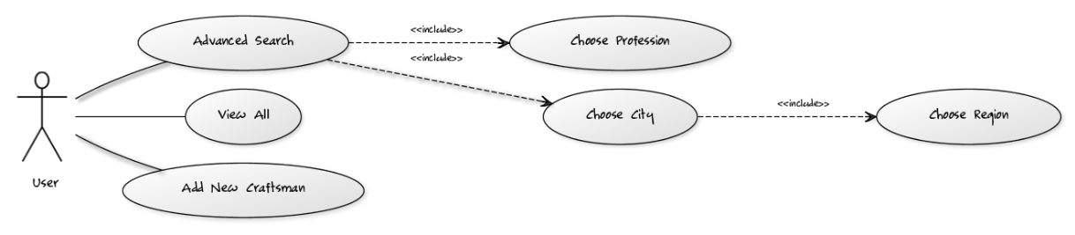

**Figure 3.1. sanay3y project use case**

|  |  |
| --- | --- |
| Actor | User |
| Description | User may transfer data from the database that the application connected to by the web service, or add data of new craftsman to the database |
| Response | Confirmation that the craftsman data was successfully added |
| Comments | There is no security permissions needed for any operation (add or search), it is a public service. |

**Table 3.1. Tabular description of the ‘Data Transfer’ use case**

**3.3. USER INTERACTION WITH MOBILE APPLICATION**

The easiest way for users to interact with any program is through buttons which has predefined events that can be used to initiate actions. When the user clicks a button at run time, the button raises the click event. When an event occurs, controls run code in response to those events. the code that should run when the user clicks the button can be wrote by creating an event handler. An event handler is a method that executes when an event occurs. When a user clicks a button, the button's click event has an event handler.

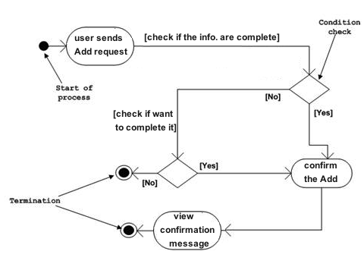

**Figure 3.2. Adding process Activity diagram**

**Figure3.2** represents activity diagram for the Adding process in sanay3y application. In the diagram three activities are identified which are associated with conditions.

* Send add request by the user.
* Confirm Adding.
* View confirmation message that the user was successfully added.

After receiving the add request, condition checks are performed to check if the information is complete or not. After the information is confirmed the view confirmation message is performed and that is marked as the termination of the process.

**3.4. THE CODE**

***3.4.1. JavaScript Code Samples***

As mentioned before we used Java Script to build the application interface and handle the buttons functions. In Titanium you have to build every simple object in your application with code, i.e. Figure3.3 representing how to add a text field to your window.

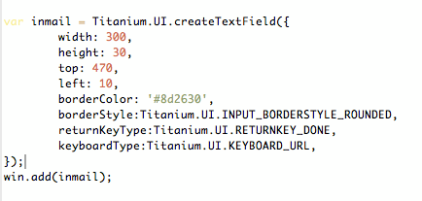

**Figure 3.3. Adding textField Code**

After completing building the interface as described previously, we handled the buttons to call the web service as shown in the next figures [ Figure3.4 Send the information of the user to the web service, Figure3.5 sends the search keys to the web service to make an advanced search, and finally Figure3.6 which sends a request to the web server to view all saved users in the system ] .

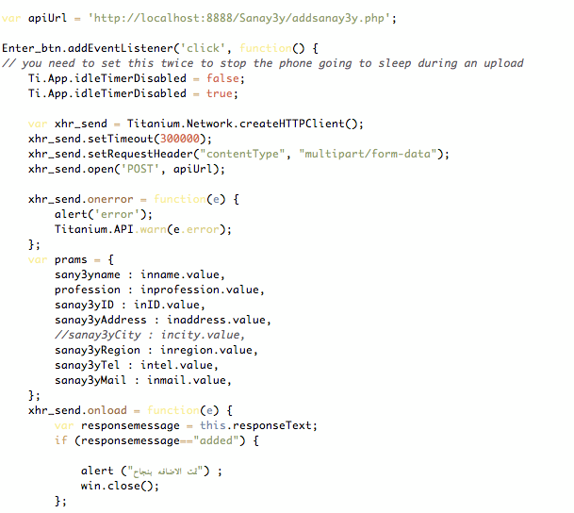

**Figure3.4 Code Sends the user data to the web server**

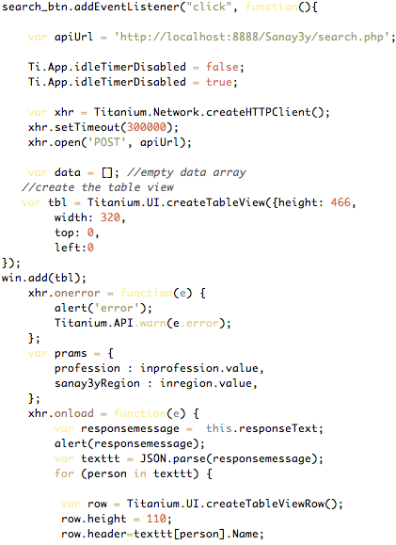

**Figure 3.5. Searching function 1/2**

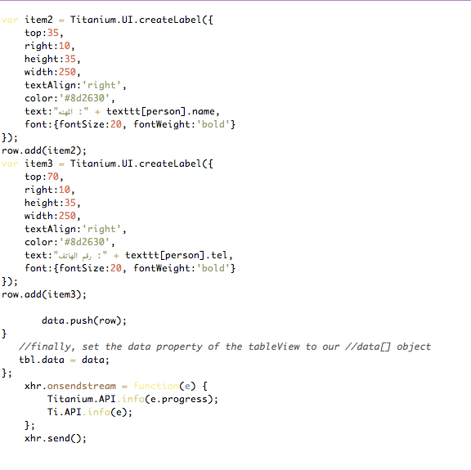

**Figure 3.5. Searching function 2/2**

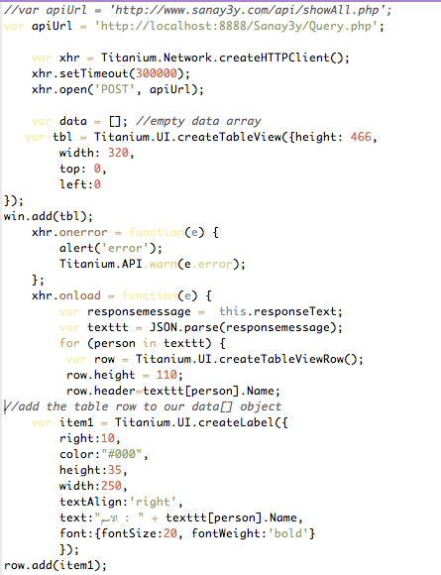

**Figure 3.6. Show All Function 1/2**

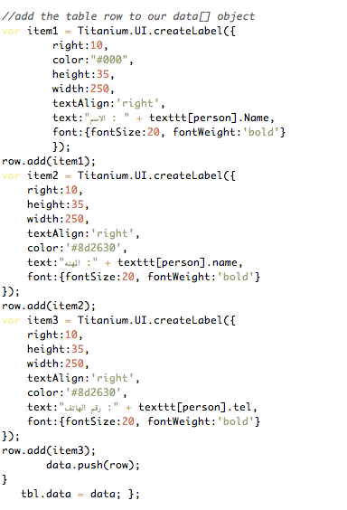

**Figure 3.6. Show All Function 2/2**

**Chapter 4. DESIGN COMPONENTS**

**Chapter 4. DESIGN COMPONENTS**

**4.1. OVERVIEW**

I

n this chapter we will explain the importance of design to produce a product that possesses users impressive, Reviews some of the pictures, logos, and icons designed for our application Sanay3y, and layouts of the work.

**4.1. IMPORTANCE OF MOBILE DESIGN**

A good mobile application starts life in the design stage. There are several aspects of the application that are formed at this stage, including among other things, layout, color, sound, content, functionality and maintainability. No reasonable person would start to build a house without designing it first, no reasonable application builders should begin construction without a design either.

Design makes things easier to use or to understand, and also serves as visual representation of your information. With the increasing information overload, our increasingly busy schedules, and plethora of apps and websites coming up everyday, good design can be an important differentiator. In an interview with Fortune Magazine, Steve Jobs said: “*Design is the fundamental soul of a human-made creation that ends up expressing itself in successive outer layers of the product*.”. When you start out with a beautiful and awe inspiring wireframe or prototype, your expectations about that product and everything associated with it is expected to also be beautiful and awe inspiring. If the initial expectations for a mobile application are low by bad or no design, then bad practices seem to find their way into the code.

**4.1. LOGO DESIGNS AND APPLICATION BUTTONS**



**Figure 4.1. The main character in Sanay3y application**



**Figure 4.2. Application Used Designs**

**4.1. MOBILE LAYOUT**

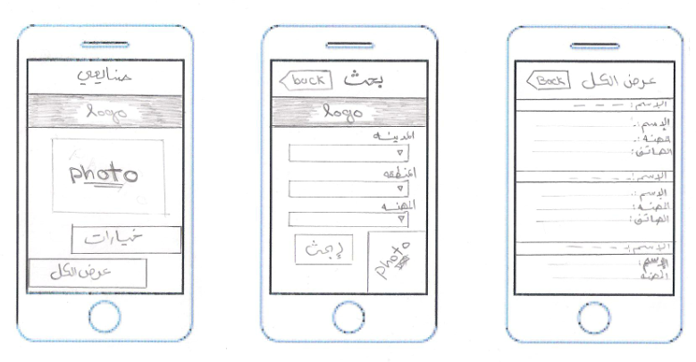

**Figure 4.5. Sanay3y Application Layout**

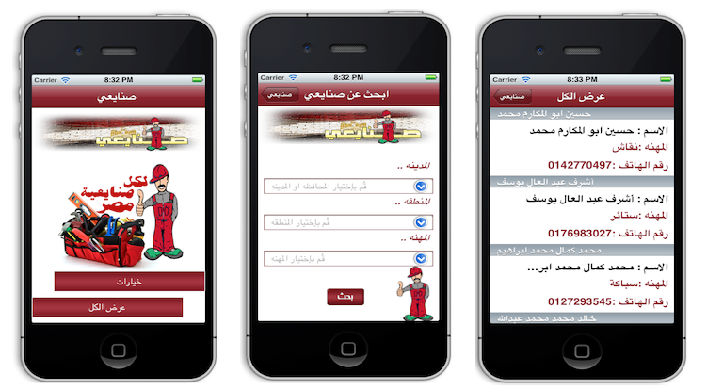

**Figure 4.6. Real Application**

**Chapter 5. INTEGRATION BETWEEN WEB AND MOBILE**

**Chapter 5. INTEGRATION BETWEEN WEB AND MOBILE**

**5.1. OVERVIEW**

T

his Chapter describes the importance of integration between web and mobile and presents the integration method used in the application. It starts by describing the integration method followed, then goes on to describe the results of this method and finally moves to conclusion.

**5.2. INTRODUCTION**

For the systems analyst, the most difficult job in specifying a system is often that of determining what is part of that system and what is not. Whatever system you develop, no matter how ambitious, no matter how grandiose, it will be part of an even larger system: even if our job were to “design the world,” we would have to recognize that the world is only a part of the solar system, which is part of a small, obscure galaxy, which is (ultimately) part of the universe.

Thus, the first major model that you must develop as a systems analyst is one that does nothing more than define the interfaces between the system and the rest of the universe, that is, the environment. For obvious reasons, this model is known as the environmental model. It models the outside of the system; the model of the inside of the system, known as the behavioral model.

In addition to determining what is inside the system and what is outside the system (which we accomplish by defining the boundary between the system and the environment), it is also critically important to define the interfaces between the system and the environment. We need to know what information comes into the system from

the external environment, and we must know what information the system produces as an output to be delivered to the external environment.

Of course, inputs and outputs are not produced at random: no information system gobbles up all available data from the universe, nor does any realistic system spew output at random for consumption by the external environment. The systems we build are rational, purposeful systems; specifically, they produce outputs as a response to an event, or a stimulus, in the environment. Thus, another critical aspect of the environmental model is that of identifying the events occurring in the environment to which the system must respond. Not all events — after all, the environment, in its totality, generates an infinite number of events! We are only concerned with those events which (1) occur in the external environment, and (2) require a response from the system.

Note that the boundary between a system and its environment, as illustrated in **Figure 5.1**, is arbitrary. It may be made by management decree, or as the result of political negotiation, or simply by accident. And it is something that the systems analyst usually has some opportunity to influence.

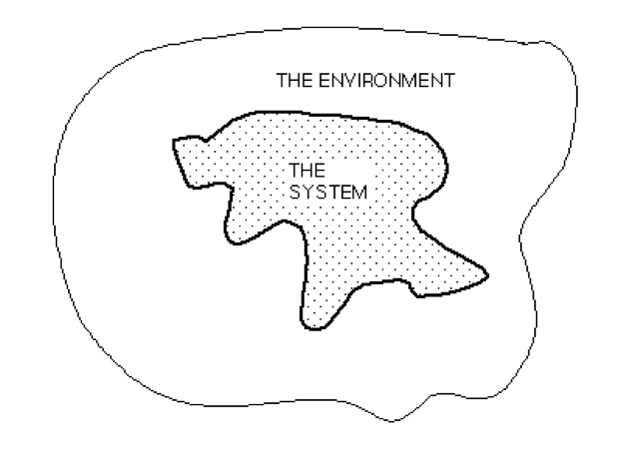

**Figure 5.1. The boundary between the system and the environment**

**5.3. INTIGRATION**

Application integration is a strategic approach to binding many information systems together. The need to integrate applications has been a requirement since business process automation was presented. Application integration can be one of the following forms: Internal Application Integration, External Application Integration, or Enterprise Application Integration (EAI). Internal application integration techniques integrate organizational applications with each other, while external application integration techniques consider integrating organizational applications with applications outside organizational boundaries. EAI platforms centrally integrate heterogeneous system landscapes on process, method and data level. Internal and External Application Integration present traditional integration levels, where EAI presents recent integration levels.

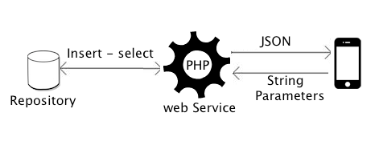

**Figure 5.2. Integration Between Web And Mobile**

**5.4. SOFTWARE ARCHITECTURES AND INTEGRATION TECHNIQUES**

Integration is one of the addressed problems that requires picking suitable software architecture as a solution. Considering how architecture works, advantages and shortages of the architecture, there are architectures that can overcome integration obstacles, and others cannot. There are many integration options that include File Transfer, Shared Database, and Messaging. Integration techniques can be categorized in either one of two categories: Data or Software. Each category satisfies an integration level. Data oriented integration techniques satisfy Data level integration, and Software integration techniques satisfy Application level integration. The rest of this chapter explains Standard Enterprise wide software and its architectures With a focus on the architecture we used in our application (N-tier architecture).

**Figure 5.3. Integration Techniques**

***5.4.1. Standard Enterprise Wide Software***

Supporting Architectures :

1. Layered Systems.
2. Client-Server.
3. N-tier software architecture.

***I. Layered Systems.***

Layered Systems use layers to separate different units of functionality. Each layer only communicates with the layer above and the layer below. Each layer uses the layer below to perform its function. Communication happens through predefined, fixed

interfaces. A Layer is a design construct. It is implemented by any number of classes or modules that behave like they are all in the same layer. That means that they only communicate with classes in layers immediately above or below their layer and with themselves. The primary disadvantage of layered systems is that they add overhead and latency to the processing of data, reducing user- perceived performance.

***II. Client – Server Architecture***

The client- server style is the most frequently encountered of the architectural styles for network-based applications. Client - Server components are: Client triggers process, Server reactive process. Clients make requests that trigger reactions from servers. Client – Server architecture mainly consists of two layers: Single Server and many clients. A Client- Server system is one in which the server performs some kind of service that is used by many clients. The clients take the lead in the communication. The basic form of client-server does not constrain how application state is partitioned between client and server components, it is often referred to by the mechanisms used for the connector implementation, such as remote procedure call or message-oriented middleware.

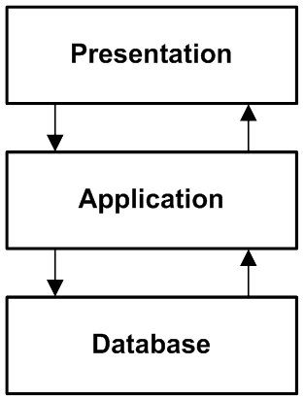***III. N-tier Software architecture.***

N-Tier architecture is a Client-Server architecture combined with the Layered architecture where N equals three or higher. Three-Tier architecture is an example of N-Tier architecture. **Figure 5.4** depicts Three-Tier Architecture.

**Figure 5.4. Three Tier Architecture**

Three-Tier architecture consists of three layers:

􏰀 **Presentation Layer:** deals with user interactions. Thin clients interface do not contain business logic, just code required to process user input, send requests to the server, and show the results of these requests.

􏰀 **Application Layer:** processes client requests. It is the actual web application that performs all functionality specific to the web application. However, it does not store the persistent data itself. Whenever it needs data of any importance, it contacts the database server.

􏰀 **Database Layer:** contains Database and Database Management System (DBMS). In the second and third tier there can be multiple instances, because of scalability, load-balancing and redundancy. N-tier architecture (with N more than 3) is really 3 tier architectures in which the middle or bottom tier is split up into new tiers. Figure 5.4 depicts the 3 tier architecture used in our project.

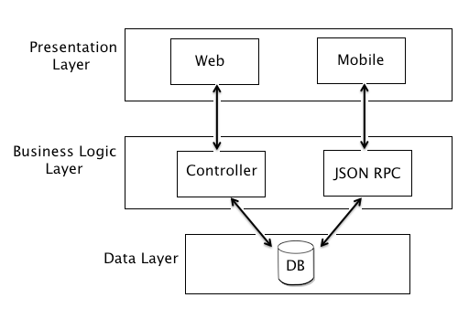

**Figure 5.5. Three Tier Architecture of Sanay3y**

***5.5. Code Samples***

An application programming interface (API) is a source code based specification intended to be used as an interface by software components to communicate with each other. An API may include specifications for routines, data structures, object classes, and variables. In simpler terms, an API refers to a set of functions built into an application, which can be used by other applications (or by itself, as our application Sanay3y), to interact with the application. An API is a great way to expose an application’s functionality to external applications safely and securely, since all functionality that these external applications can do is limited with what functionality is exposed in the API. We wrote our APIs in **PHP** as follows :

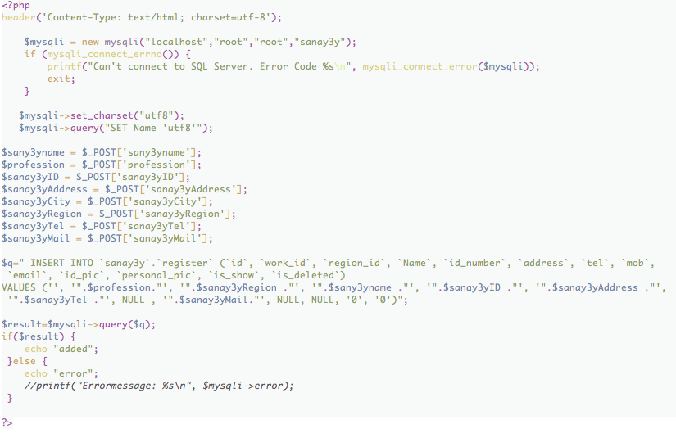

**Figure 5.6. Add API**

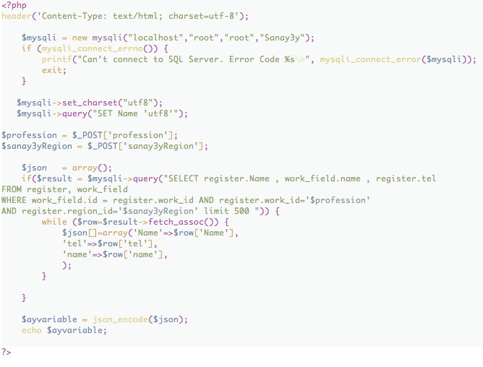

**Figure 5.7. Advanced Search API**

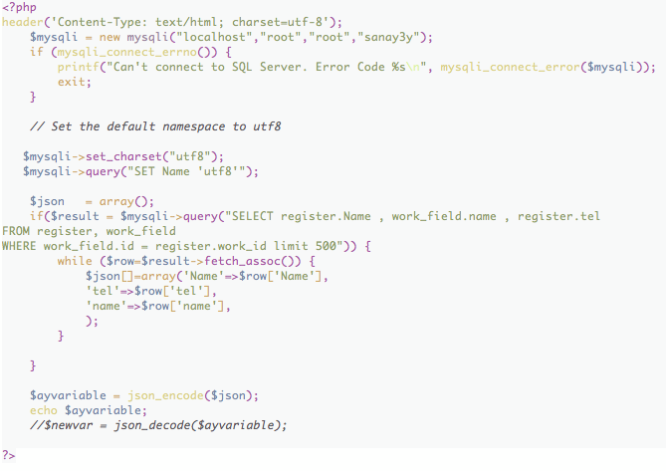

**Figure 5.8. Show All API**

**Chapter 6. PROJECT OUTCOME**

**Chapter 6. PROJECT OUTCOME**

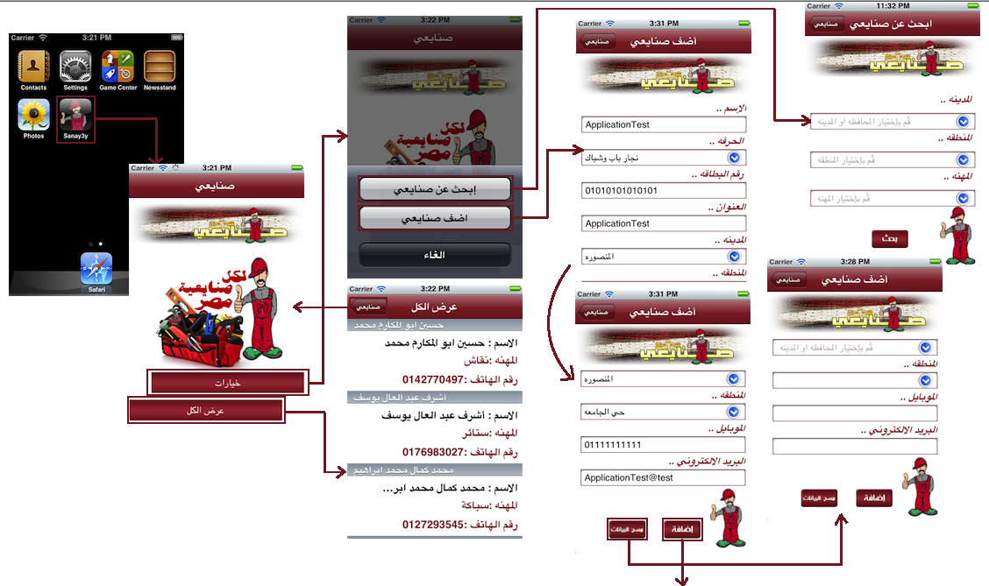

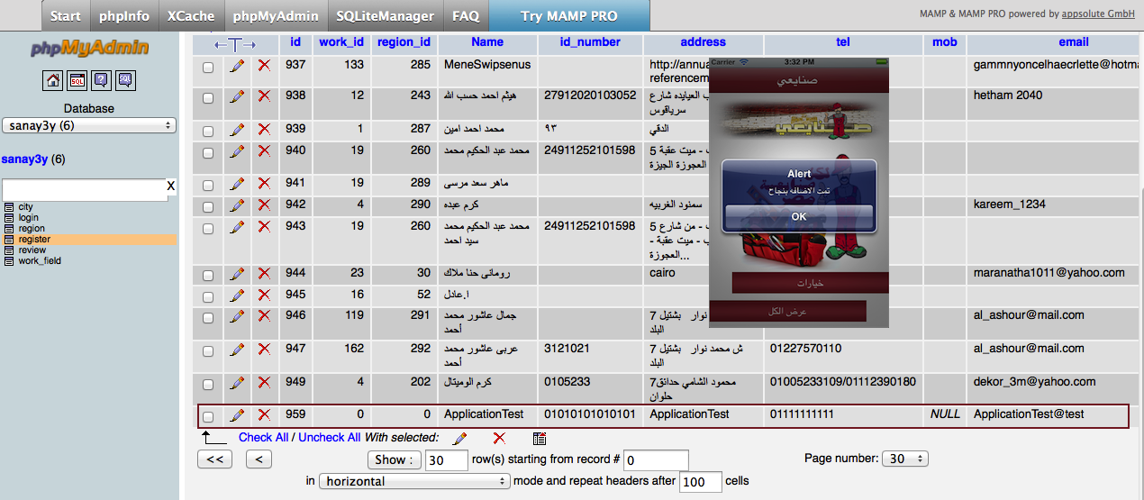

**Figure 6.1. Sanay3y Application Flow**

**Chapter 7. CONCLUSION AND FUTURE WORK**

**Chapter 7. CONCLUSION AND FUTURE WORK**

**7.1. CONCLUSION**

T

heuse of Smartphones are increasing day by day. Due to such increase in demand ultimately there is increase in supply. While there is increase in supply we need Mobile Application developers to develop new applications for different mobile platforms. Mobile application development is an emerging as well as relatively lucrative field with many organizations and independent developers plunging in great numbers to make hay while it lasts. It is expected to last as long as man is in love with the hand-held devices that make life so easy and accessible. Today mobile is obviously not seen just as an instrument to make calls. Mobile app development has led to the creation of innumerable innovative and unique applications such as web browsing, email, Internet faxing, games, wireless information services etc.

There are certain elements that are decisive in deciding what kind of a mobile application one should get made:

**1. Platform:** The cellphone application are different for different platforms and one application cannot be made to run on all the platforms. Each of the mobile platforms is quite different and therefore can run certain applications that are developed for a specific technology. We have chosen iPhone for our application because it is widely used, and available. iPhone SDK is a rich SDK that helped us through the development process.

**2. Customer base:** Whenever deciding to outsource the requirements of mobile software to a company it is important to determine the kind of audience you are targeting at. The target audience determines to an extent whether it will be a business mobile application or an application that will be used by individual customers. This would help in figuring out the design and technology solutions for the mobile software. Distribution capabilities of Sanay3y App using Apple App Store will help us a lot in reaching diverse customers. Because we have been working with an NGO (Non Governmental Organization), we had the accessibility of reaching thousands of online Sanay3y records that we have integrated and utilized in the project. Targeting iPhone users helped us identifying the requirements of the users, committing to Apple guideleines in developing applications helped us a lot.

**3. Pricing and timeframe:** It is important to take into account the costing of the mobile app development and the exact time frame for launching the product. Researching your competitors’ products will help in determining the kind of price strategy you should adopt while to get the maximum return on investment it is also pertinent to launch at the right time. Investing our graduation project time and effort in presenting a real life application that is useful for Community Services turned out to be an interesting experience. In conjuction with Sanay3y NGO, we are presenting this application for free to be utilized by all iPhone users.

**7.2. FUTURE WORK**

Presenting same application for different platforms is the next step to take. We need to present this application for BlackBerry, Android Smart Phones. We might present a Tablet edition in case Sanay3y NGO thought about adding new features. Embedding a business model in this application is an important step. Sanay3y NGO were thinking about utilizing Sanay3y Mobile App in raising funds, or directing users for future phone calls. We are working currently on that!

**REFERENCES**

* Abdul Karim, N.S., Darus, S.H., Hussin, R., 2006. Mobile phone applications in academic library services: A students’ feedback survey. Campus-Wide Information Systems.
* A news recommender for the mobile web H.J. Lee a, Sung Joo Park b (2007) Retrieved july 20, 2012, from: <http://www.business.kaist.ac.kr>
* <http://www.mamp.info/en/mamp-pro/index.html> (2012 ) Retrieved july 21, 2012 .
* Turning cell phones into lifelines By [Marguerite Reardon](mailto:maggie.reardon@cnet.com?subject=FEEDBACK:%20Turning%20cell%20phones%20into%20lifelines) - Staff Writer, CNET News (2006) Retrieved july 21, 2012, from: <http://news.cnet.com/Turning-cell-phones-into-lifelines/2100-1039_3-6140794.html>
* Structured Analysis Wiki by Ed Yourdon (1989) Retrieved july 22, 2012
* Project Management Methodologies book by Jason Charvat (2003) Retrieved june 3, 2012
* Designing the mobile user experience book by barbara ballard (2007) Retrieved 2012

# Creating an API-Centric Web Application By [Nikko Bautista](http://net.tutsplus.com/author/nikko-bautista/) on Dec 30th 2011 Retrieved July 22, 2012 from : http://net.tutsplus.com/tutorials/php/creating-an-api-centric-web-application/

* Mapping Different Software Architecture Paradigms to Different Integration Techniques: Highlighting Driving and Restraining Forces for Each Paradigm

paper by A. M. Riad ,Hazem M. El-Bakry,and H. A. El-Ghareeb, (2009) Retrieved June 28, 2012 .